India tour 14-30 November 2018
Jodhpur in Desert
Wednesday 21st November 2018
Day 8:- bus to Jodhpur, located south East from Jaisalmer 328klms through semi-arid desert area of Rajasthan.
Ablutions and breakfast over by 7.30 and travel case repacked and outside room door for collection and delivery to the waiting bus for today’s long drive. First Alan had to settle his account at reception desk for the previous day’s lunch at 915Rupees. He gave the male clerk a 2,000 Rupee note and got change of 85Rupees. He pointed out that the change should also include a 1,000Rupee note as a 2,000rupee note was offered. A quick apology and 2 by 500Rupee notes given. Probably thought the old fellow would not notice!
The bus left the hotel at 9.00am and continued east for several kilometres until a turn south east was made on a less than highway standard road in the direction of Jodhpur. Still relatively desert country being transgressed with occasional sand hills with acacia shrubs scattered everywhere but otherwise generally flat country. The bus driver has to negotiate passing slower overladen trucks, wandering cows, all types of transport vehicles, from camel drawn carts or buffalo drawn carts, motorbikes laden with either people or goods etc. He does a magnificent job, aided by his trusty driver assistant whose job is to be a lookout for the kerbside traffic. Alan reckons that the Indian taxi drivers in OZ get their training first on Indian roads and then are very competent driving in OZ.
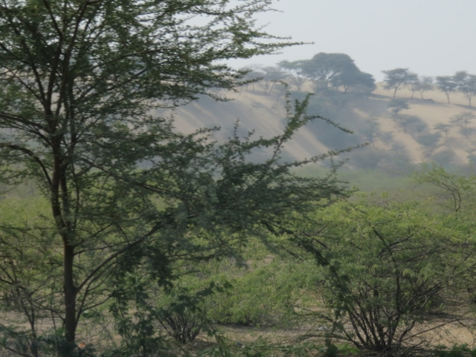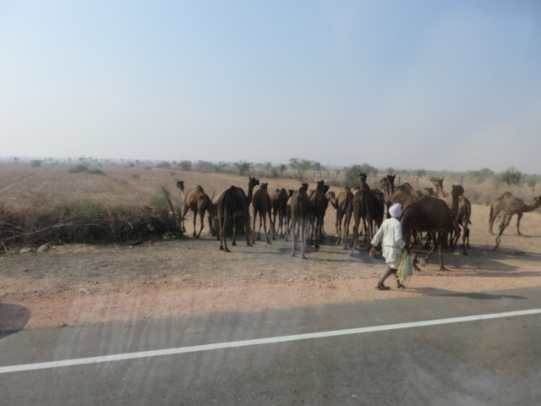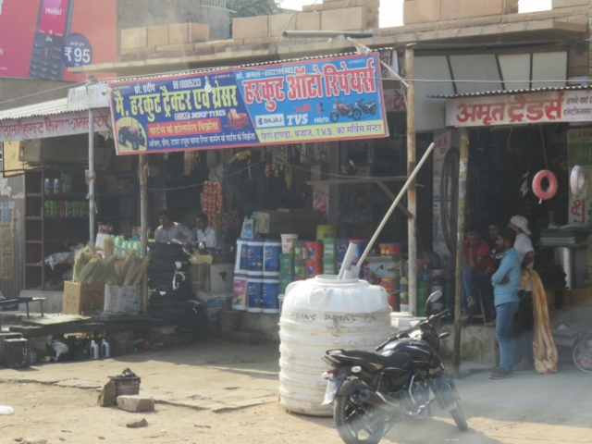
Acacia shrubs and sand hills Camel herder on side of road Small village shops with everything displayed.
A lunchtime comfort stop turned out to be a lunch venue as well with Alan ordering his standard mushroom soup with nann bread + a refreshment small bottle of beer (to quench any hot stuff if needed). Continuing onto Jodhpur, the bus arrived at the city at 4.30pm. So it took about 7 hours to drive the 328klms! However the stop was not at the hotel but the Mehrangarh Fort for a visit.
The Fort is an imposing edifice set upon a hill not far from the present city. It has another imposing main gate at the entrance called the “Lahapol”. At the side of this gate there are 15 hand prints called the “Sati Marks” of Maharaja Man Singh’s widows who threw themselves on his funeral pyre in 1843 when the Fort was besieged. Inside the Fort, the tour visited the palaces MotiMahal or “Pearl Palace” as it is known. The Sukh Mahal or “Pleasure Palace” and the Phool Mahal or “Flower Palace”
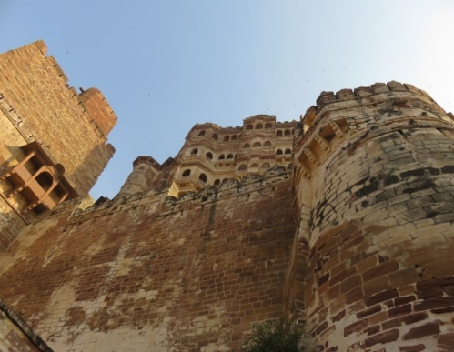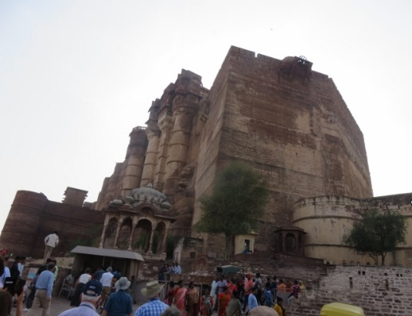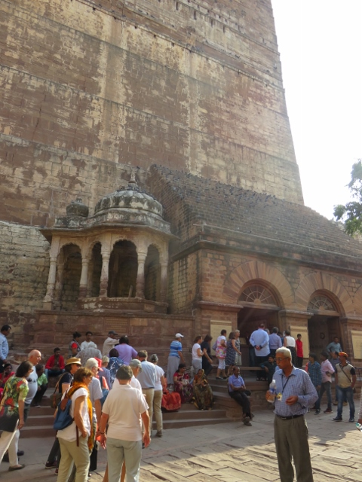
Mehrangarh Fort on hill top approaching the massive gate lining up for tickets to get inside.

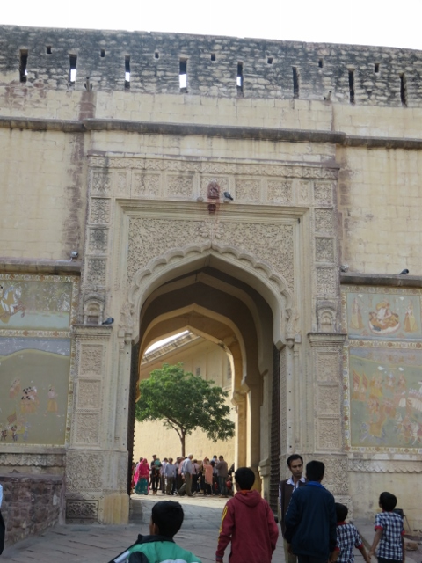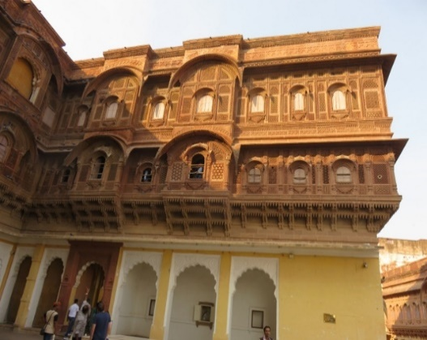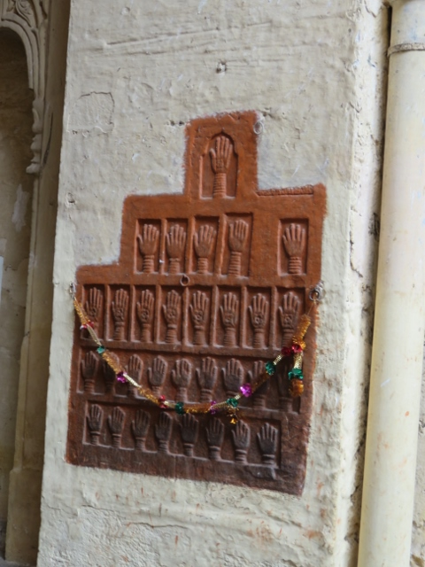
Crowds outside gate to Fort palace decorations on outside hand prints of the “Sati Marks” widows.
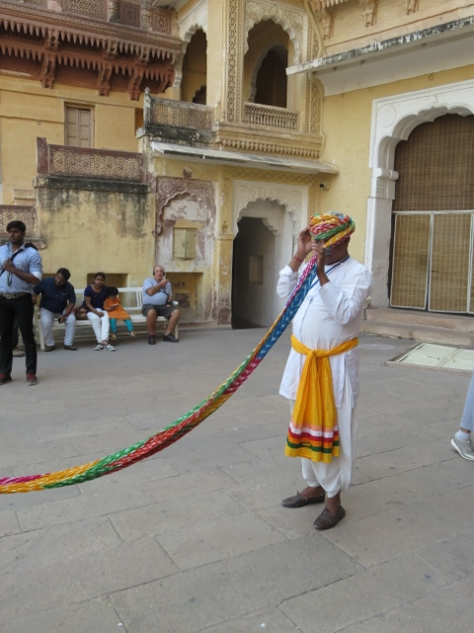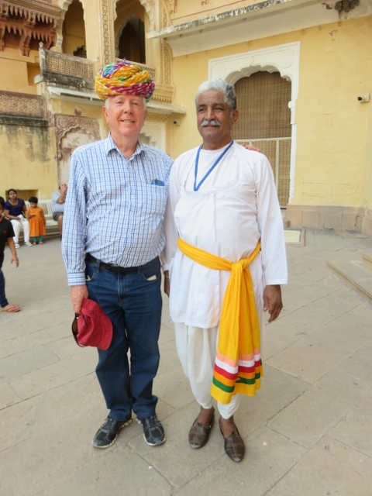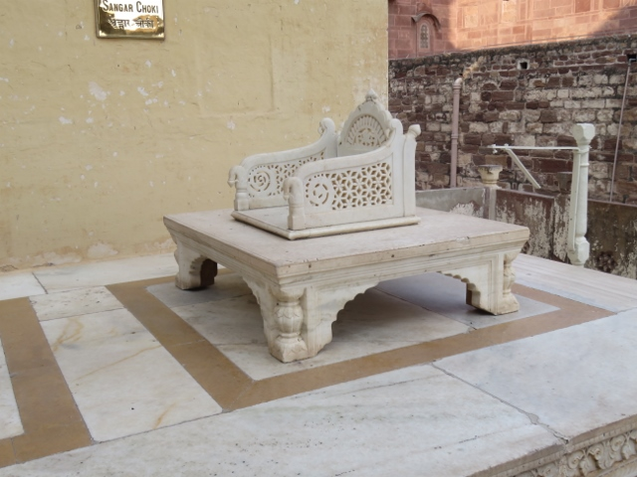
Turban demo in wrapping on head Alan allowed to have a go! Maharaja marble chair in courtyard.
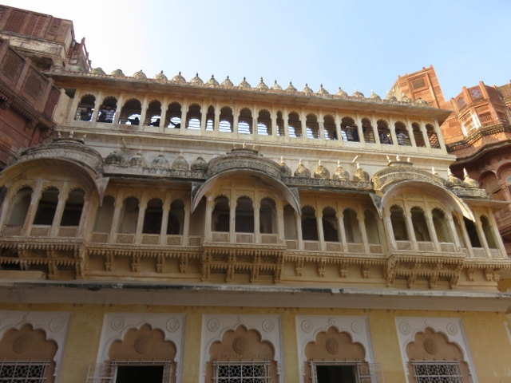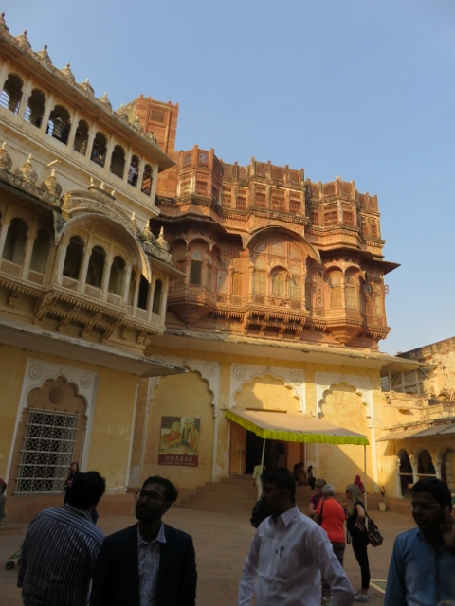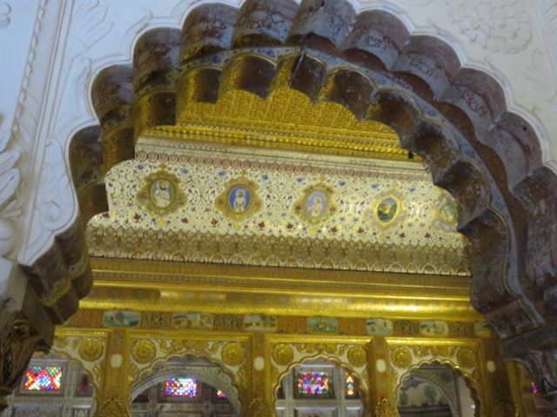
Façade of another palace setting sun rays on palace to left panelling décor in palace room.
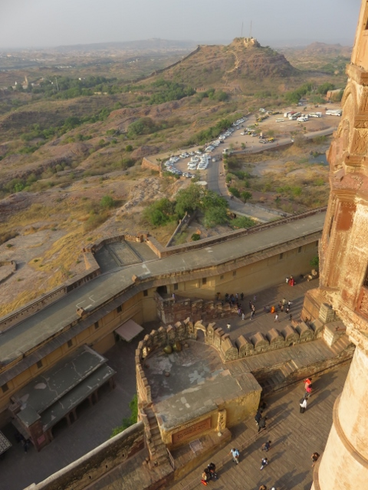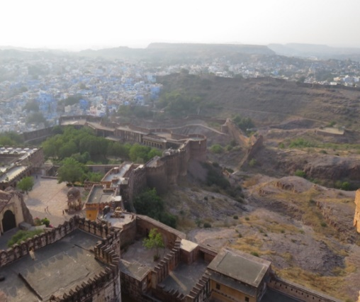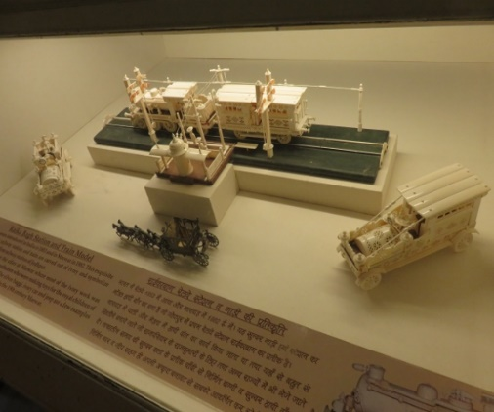
Lookout from near top of Fort another view of Jodhpur in distance ivory toys carved for Maharaja’s boys.
After the visit to the Mehrangarh Fort, the tour visited a nearby marble edifice known as the “Jaswant Thada”. This is a cenotaph built in 1899 as a memorial to Maharaja Jaswant Singh 11. There were several smaller monuments surrounding the lovely gardens and lawns at this place. These contained the ashes of the noble persons cremated at this site.
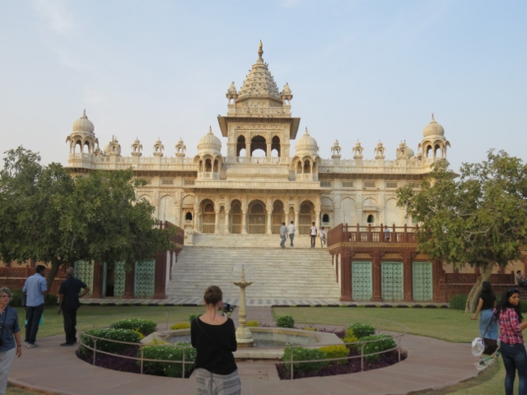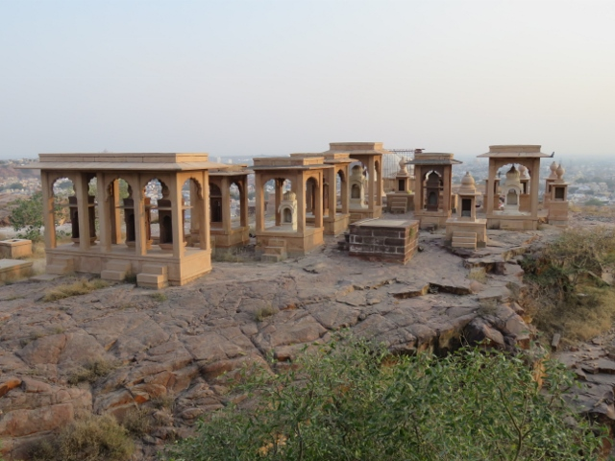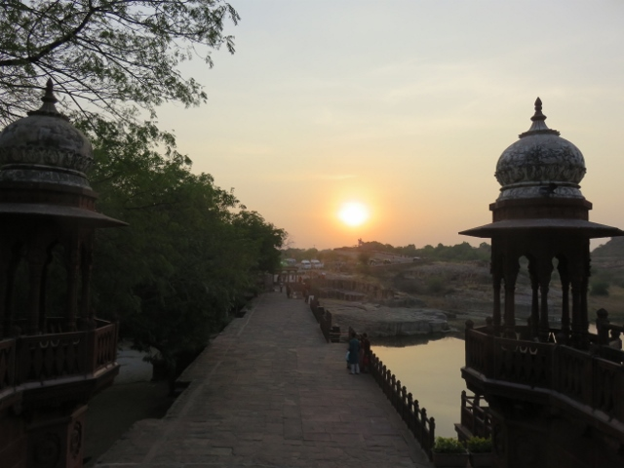
Marble “Jaswant Thada” building monuments containing deceased ashes setting sun from cenotaph.
Back on the bus after these inspections for a drive, not to the hotel, but to a wholesale fabric outlet. This is a building in the suburbs of Jodhpur where the craftsperson’s works are on display for the tourists to have a look over and purchase any items that catch their fancy!
Some magnificent shawls and bed spreads made from cashmere and other exotic fibres were displayed. The creativity of the workers is just simply amazing. Several members of the group, including Alan, made purchases of more than one item. Oh well so much for instructions to not bring anything home! That went for Father Max as well. His instructions from his wife Ros;-“before you decide to buy anything, first stop and picture where you are going to place in in our home!” Apparently not much space left at home from all the previous overseas trips purchases.
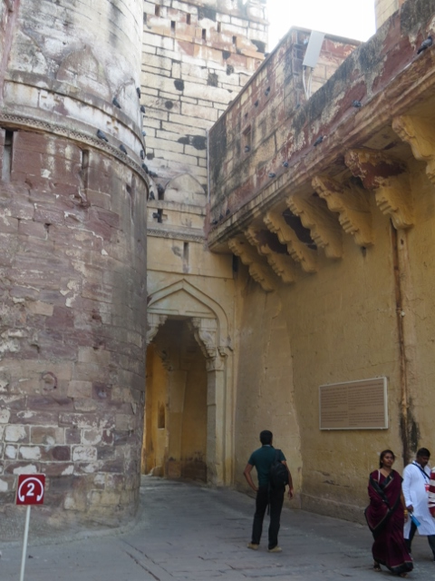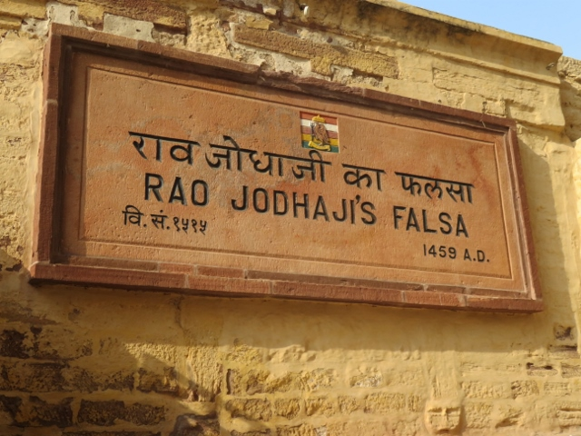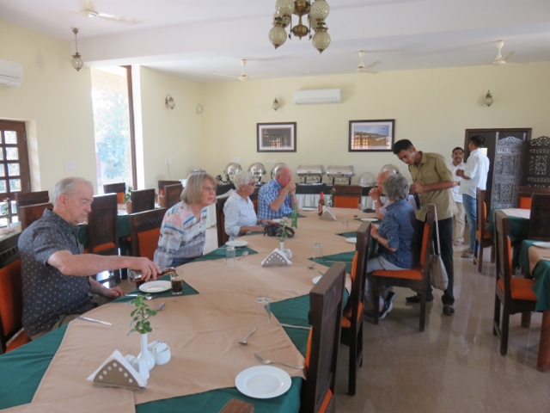
Exit archway from Fort Plaque for name of worker buried in fort wall* Lunch earlier in day.
The fabric wholesalers having satisfied their customers, the group got back on the bus and arrived at the Ajit Bhawan hotel in Jodhpur at 7.30pm. This hotel is another fort like structure pretending to be a 5 star hotel. Alan was allocated room 80. The hotel rooms are very large and their facilities good.
The dinner, in a special dining room, was served to the group on an individual basis instead of the usual buffet style. Needless to say it took too long for the meals to be served. Alan’s meal, tomato soup and salad, sweet corn dish with mutton (very hot chilli), chicken and rice, and Indian bread. Sweets;- hard brownie squares +- round balls of something undescribed +- a scoop of vanilla ice-cream.
A tiring day after such a long drive. Bed welcomed by 9.45pm.
- This chap was buried alive of his own volition in the walls of the fort to appease the “demon” that was hindering the fort’s construction. It must have worked as the Maharaja decreed the plaque be made.

